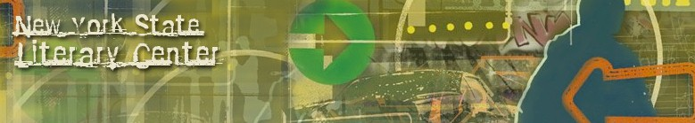
New York State Literary Center
BOOKS BY FAMILIES DEALING WITH INCARCERATION
Incarceration: Its Impact on Children and Families
Compiled by Dale Davis

Mariame Kaba. Missing Daddy. AK Press, 2019.
https://www.akpress.org/missing-daddy.html

Jonae, Jesse, Layonnie, and Kahliya of Reach Incorporated. Deena Misses Her Mom. Shout Mouse Press, 2017.
http://www.shoutmousepress.org/cart1/deena-misses-her-mom

Pat Pratt. “Ex-Inmate Writes Book to Help Children Cope with Absence.” Boonville Daily News, April 8, 2019.
https://www.boonvilledailynews.com/news/20190408/ex-inmate-writes-book-to-help-children-cope-with-absence?template=ampart

Incarceration. Social Justice Books. A Teaching for Change Project.
https://socialjusticebooks.org/booklists/incarceration/

Jacqueline Woodson. Visiting Day. Penguin Random House, 2015.
https://www.penguinrandomhouse.com/books/317982/visiting-day-by-jacqueline-woodson-illustrated-by-james-ransome/9780147516084/

© 2019 New York State Literary Center All Rights Reserved

